# Solution 1

[t,y] = ode45(@deriv,[0,0.01],[0,0,0]);

figure(1)

plot(t,y(:,1),'b');

title('Position of mass');

xlabel('Time - [s]');

ylabel('Displacement- [m]');

figure(2)

plot(t,y(:,3),'r');

title('Current in system');

xlabel('Time - [s]');

ylabel('Current - [A]');

function XDOT = deriv(t,X)

    % System Parameters

    m = 0.002;

    k = 8e5;

    c = 2;

    Kf = 16;

    Kb = 16;

    La = 2e-3;

    R = 12;

    % Rename states

    x = X(1); xd = X(2); i = X(3);

    % Initiate forcing function

    v = 10;

    % write the non-trivial equations using nice names

    xdd = (-c*xd - k*x + Kf*i)/m;

    i_dot = (v - R*i -Kb*xd)/La;

    XDOT = [ xd; xdd; i_dot] ;  %return the derivative values

end

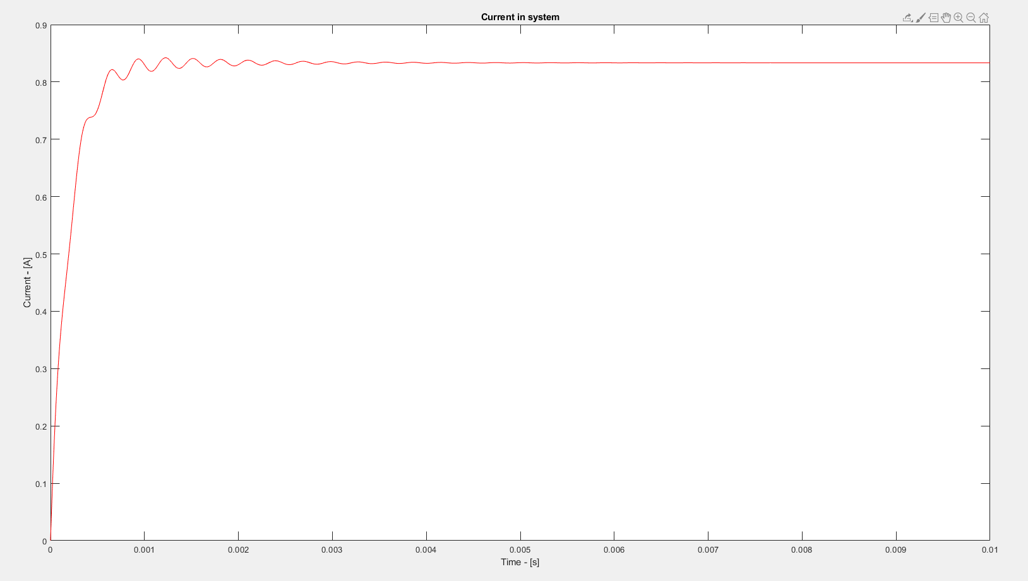

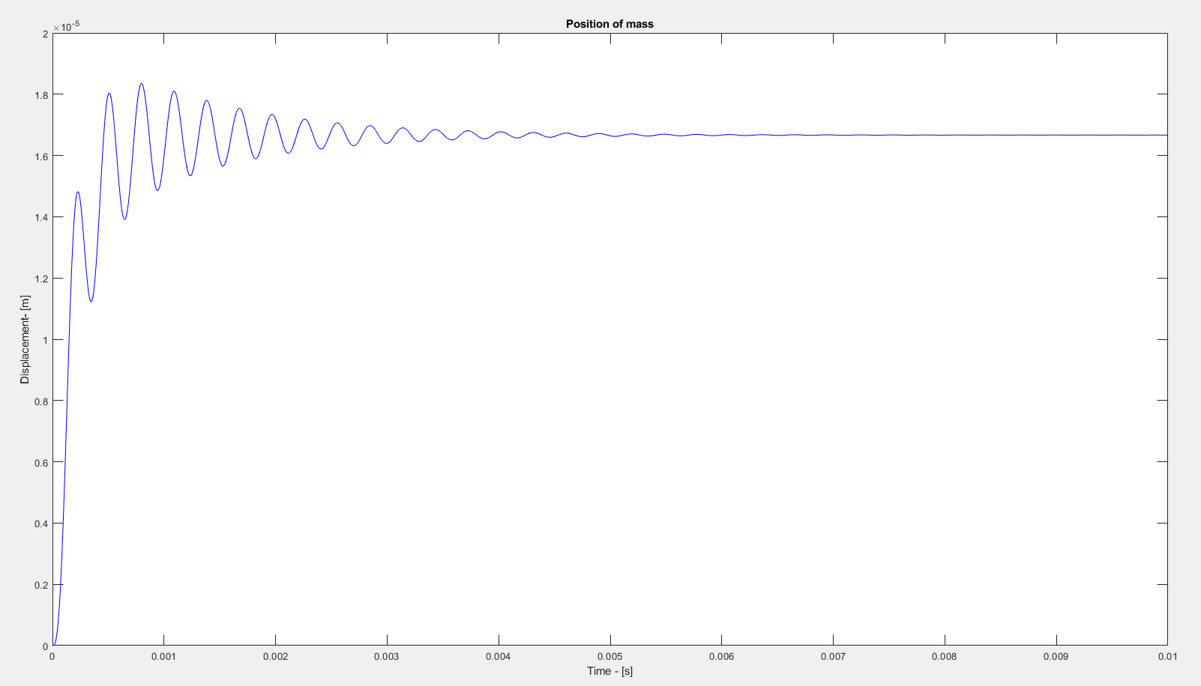

# Solution 2

clc

global c;

c = 2;

[t1,states1] = ode45(@deriv,[0,0.01],[0,0,0]);

c = 10;

[t2,states2] = ode45(@deriv,[0,0.01],[0,0,0]);

c = 20;

[t3,states3] = ode45(@deriv,[0,0.01],[0,0,0]);

c = 50;

[t4,states4] = ode45(@deriv,[0,0.01],[0,0,0]);

figure(1)

plot(t1,states1(:,1))

hold on

plot(t2,states2(:,1))

hold on

plot(t3,states3(:,1))

hold on

plot(t4,states4(:,1))

hold off

title('C Parameter Study')

xlabel('Time - [s]')

ylabel('Position - [m]')

legend('c = 2', 'c = 10', 'c = 20','c = 50')

function XDOT = deriv(t,X)

    % System Parameters

    m = 0.002;

    k = 8e5;

    global c;

    Kf = 16;

    Kb = 16;

    La = 2e-3;

    R = 12;

    % Rename states

    x = X(1); xd = X(2); i = X(3);

    % Initiate forcing function

    v = 10;

    % write the non-trivial equations using nice names

    xdd = (-c*xd - k*x + Kf*i)/m;

    i_dot = (v - R*i -Kb*xd)/La;

    XDOT = [ xd; xdd; i_dot] ;  %return the derivative values

end

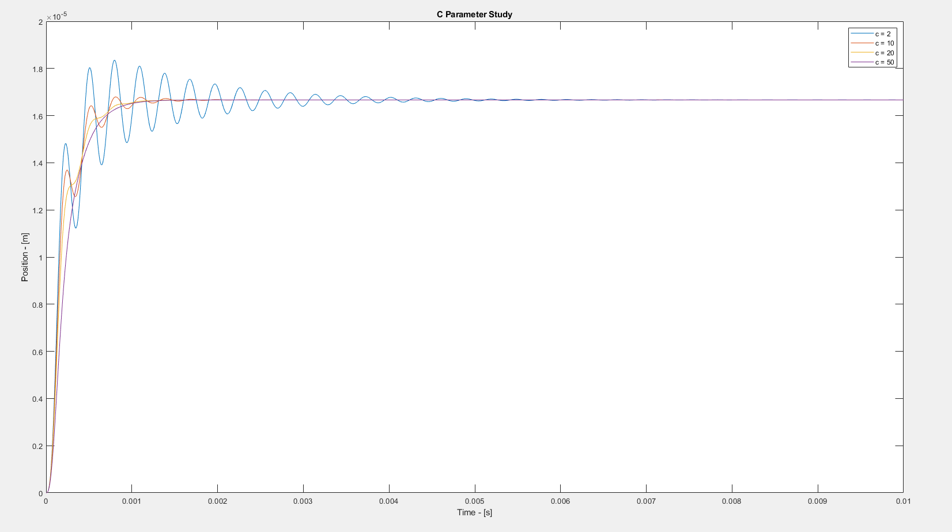

# Solution 3

[t,y] = ode45(@deriv,[0,0.01],[0,0,0]);

x_analytic = (1.67 - 0.3*exp(-500.*t).*sin(20000.*t + 1.55))/1e5;

figure(1)

plot(t,y(:,1),'b');

hold on

plot(t,x_analytic)

hold off

title('Solution Comparison');

xlabel('Time - [s]');

ylabel('Displacement- [m]');

legend('Simulation','Analytic')

function XDOT = deriv(t,X)

    % System Parameters

    m = 0.002;

    k = 8e5;

    c = 2;

    Kf = 16;

    Kb = 16;

    La = 2e-3;

    R = 12;

    % Rename states

    x = X(1); xd = X(2); i = X(3);

    % Initiate forcing function

    v = 10;

    % write the non-trivial equations using nice names

    xdd = (-c*xd - k*x + Kf*i)/m;

    i_dot = (v - R*i -Kb*xd)/La;

    XDOT = [ xd; xdd; i_dot] ;  %return the derivative values

end

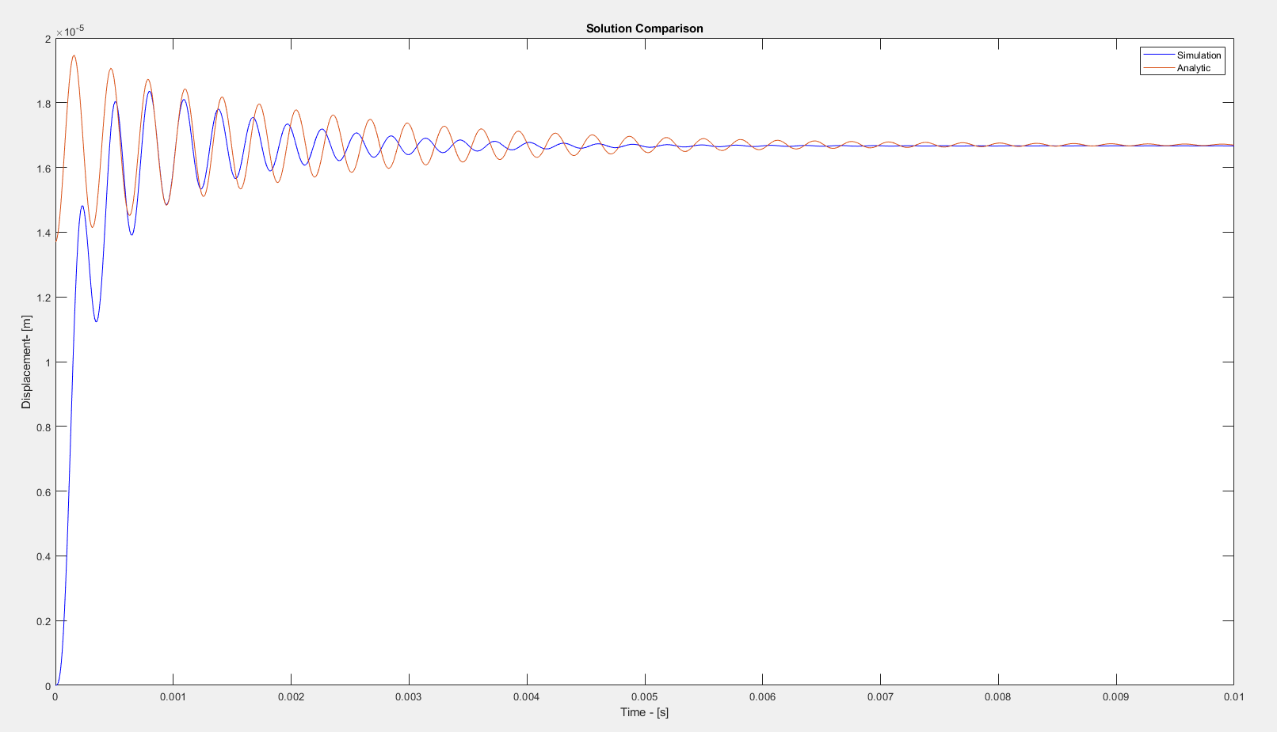

The analytic solution and simulation both have the same steady state value, but the transient response have different frequencies and amplitudes. They also start at different initial conditions.

# Solution 4

m = 0.002;

k = 8e5;

c = 2;

Kf = 16;

Kb = 16;

La = 2e-3;

R = 12;

Va = 10;

num = [Kf];

den = [(m*La),(c*La+m*R),(k*La + c*R + Kf*Kb),(k*R)];

T = tf(num,den)

[y,t] = step(T);

plot(t,y*Va)

title('System Response')

xlabel('Time - [s]')

ylabel('response')

